**Instructions** (**READ AND FOLLOW INSTRUCTIONS CAREFULLY**):

~~−~~ **In case of CHEATING, COPIED material or any unfair means would result in ZERO marks.**

~~−~~ Mention your name and ID above and write solution in this file and then submit in word or PDF format.

~~−~~ Submissions will only acceptable in hardcopies

**Assignment**

**–**

**2**



**PAF**

**-**

**Karachi Institute of Economics and Technology**

**College of Computing and Information Sciences**

**-**

**North Campus**

**Internet & Intranet Architecture**

~~−~~ Late submission will result in mark deduction

**Submission Deadline: 12-05-2022**

**Instructions (for Topology Configuration)**

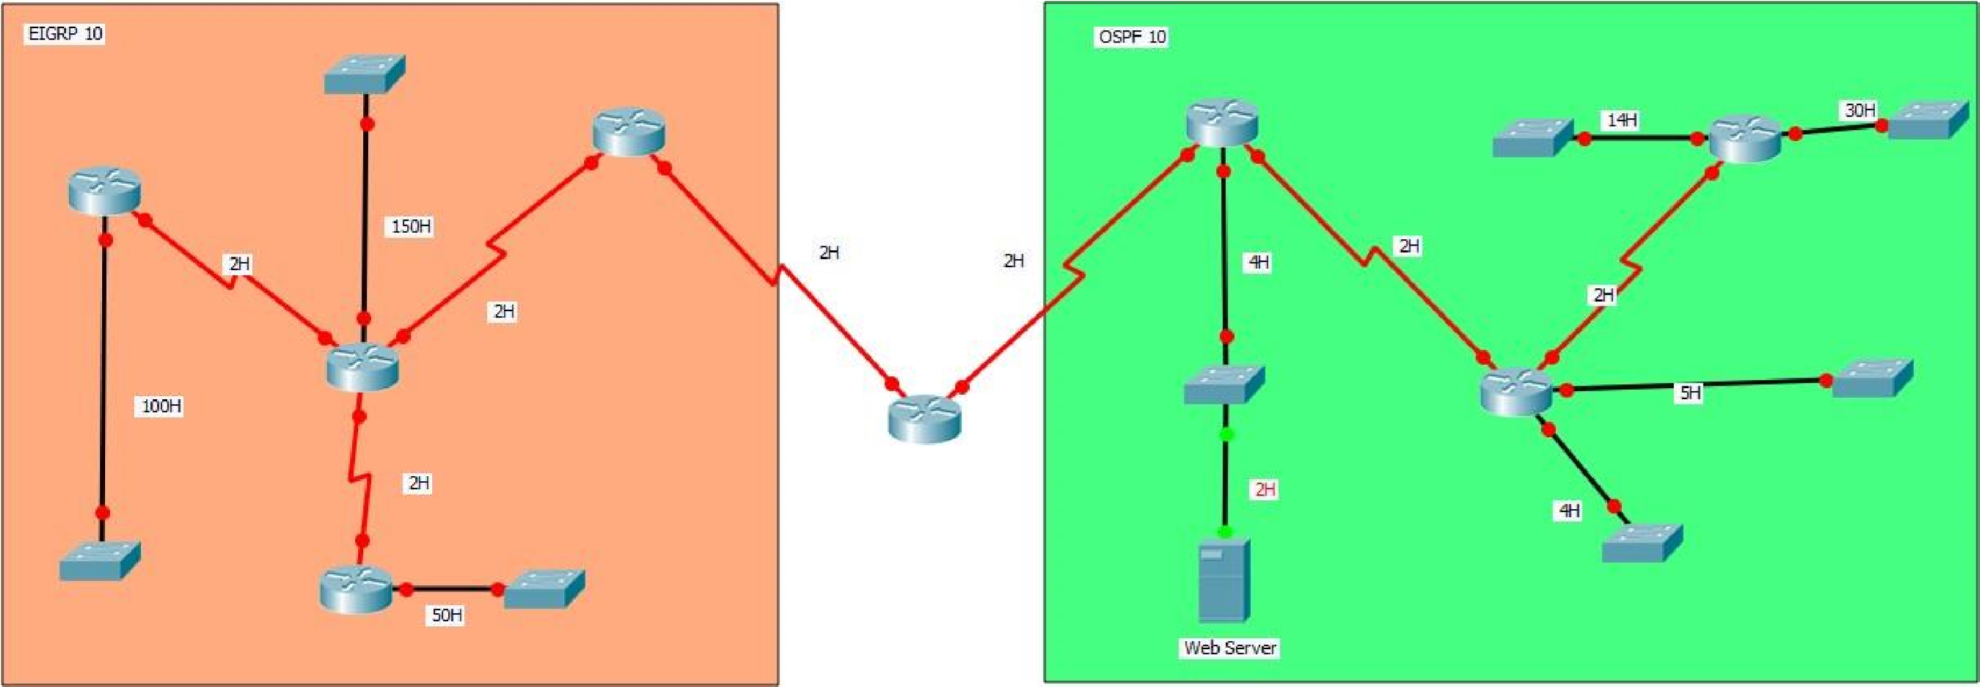

* Change all router hostname with your name
* Use major network which is assigned to you only
* Configure EIGRP 10 on left side.
* Configure Route Redistribution
* Configure the OSPF 10 on right side.
* Connect at least 2 PC with each switch.
* All end devices should communicate with each other.
* All end devices should communicate web server but only OSPF side end devices should access website.
* Submit screenshot of topology with network labels
* Submit screenshots of routing table of all routers
* Submit screenshot of ACL configuration
* Submit screenshot of web server
* Submit screenshot of 1 PC accessing website and 1 PC from EIGRP that is not allowed to access website

**If anyone failed to follow any instruction I will deduct 1 marks for each instruction.**

**[Solution]**

**NAME: Syed Muzzamil Waseem**

**SID: 11067**

**CID: 109138**

**TOPOLOGY:**

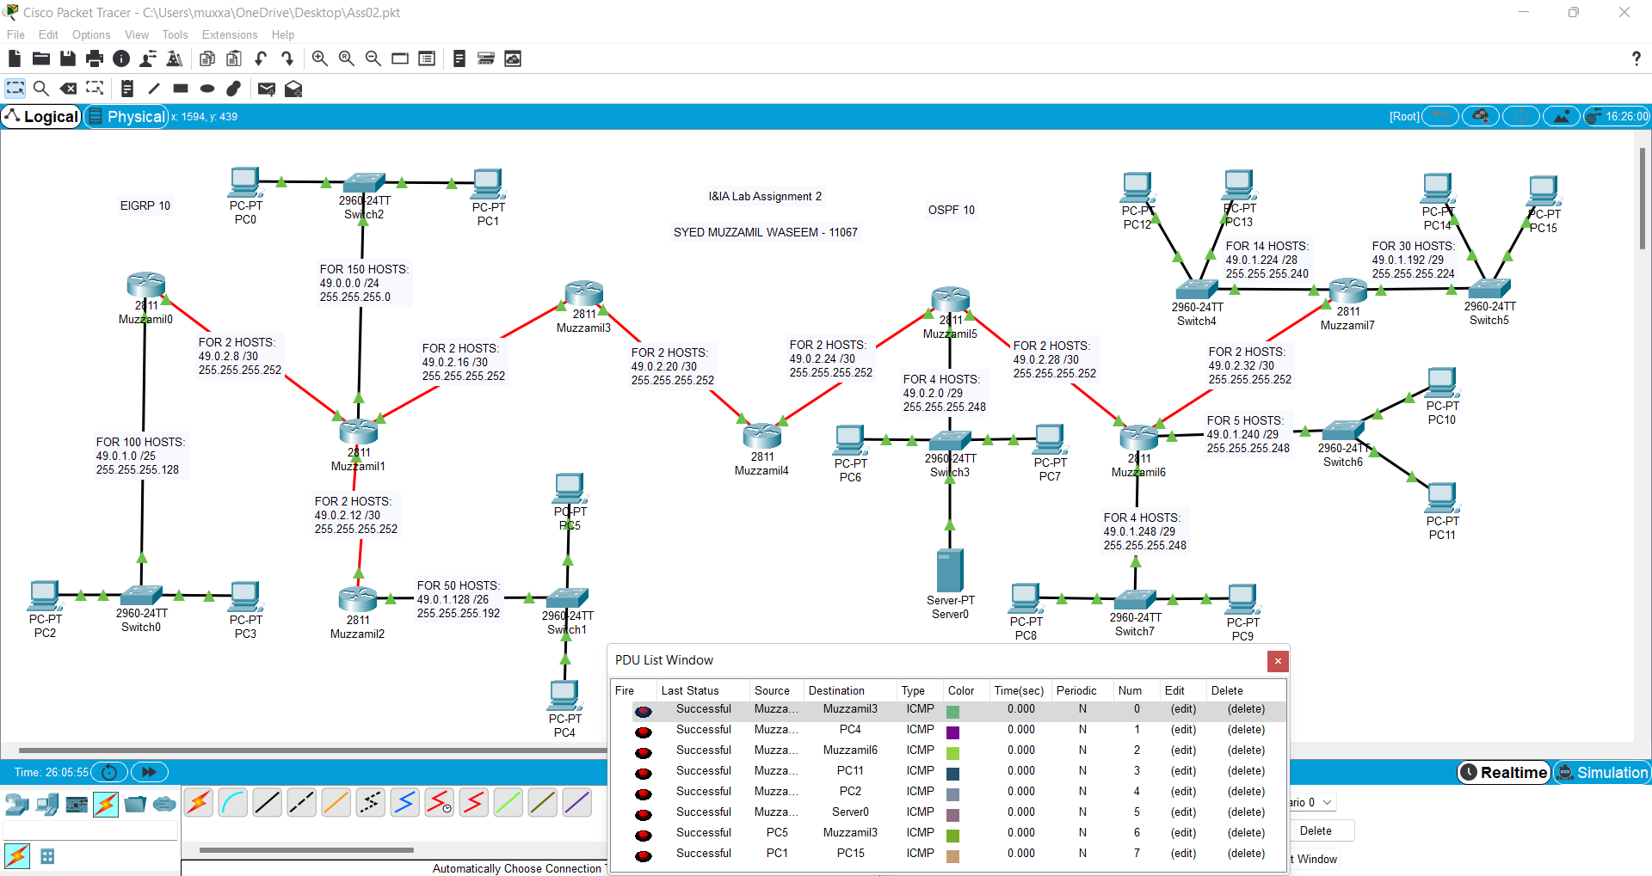

**EIGRP CONFIGURATION:**

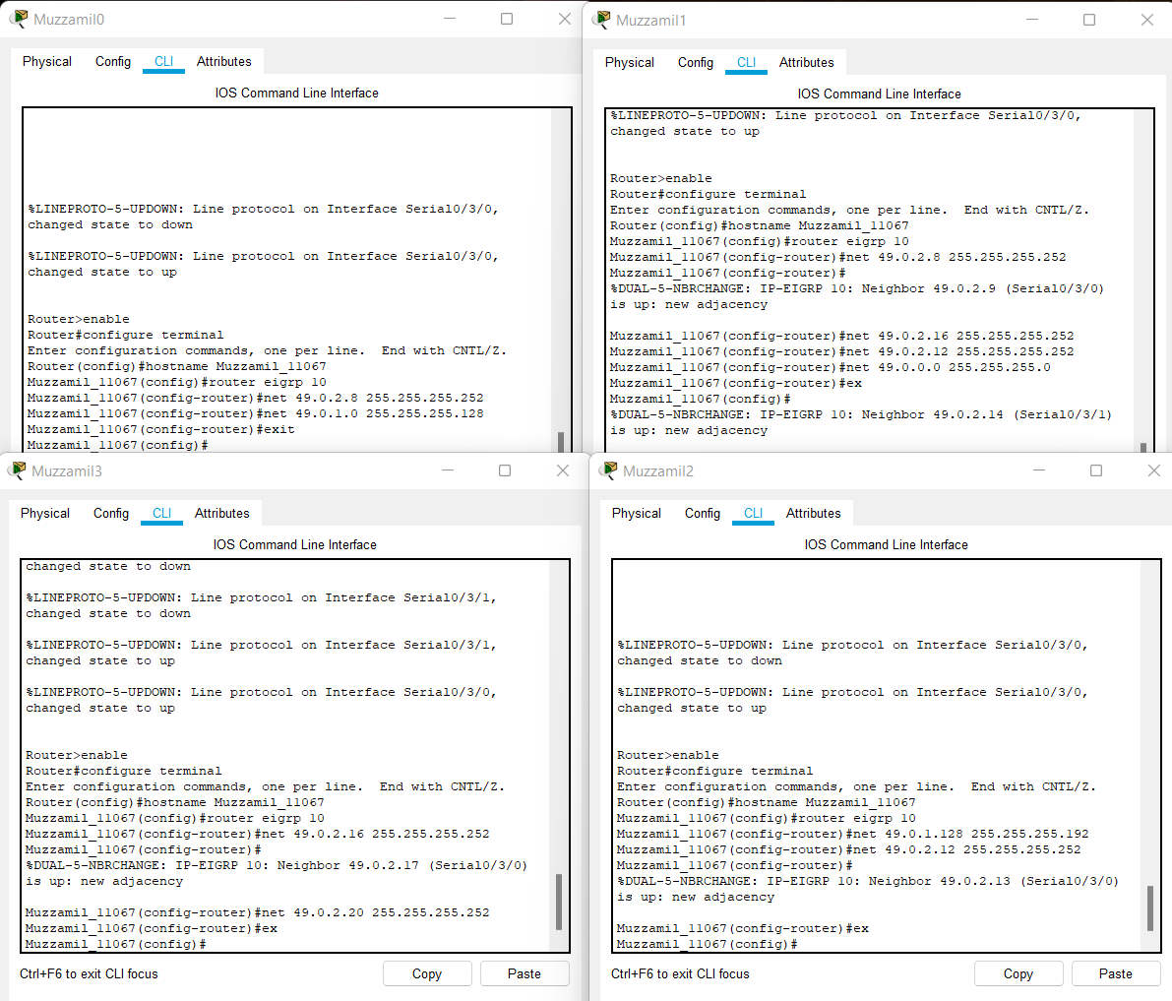

**EIGRP ROUTING TABLES:**

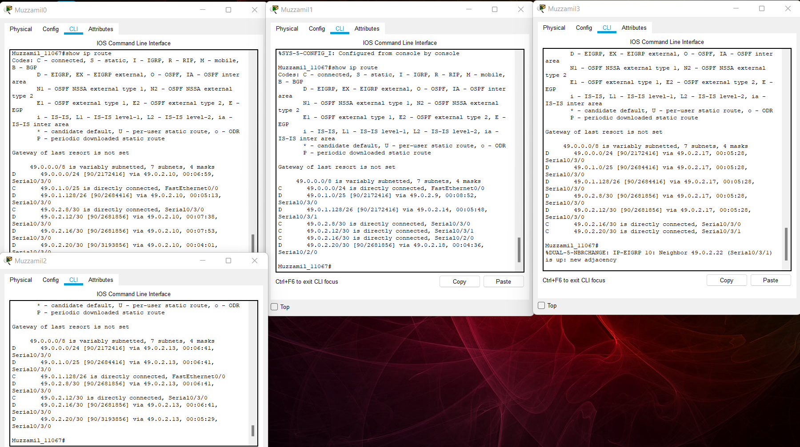

**OSPF CONFIGURATION:**

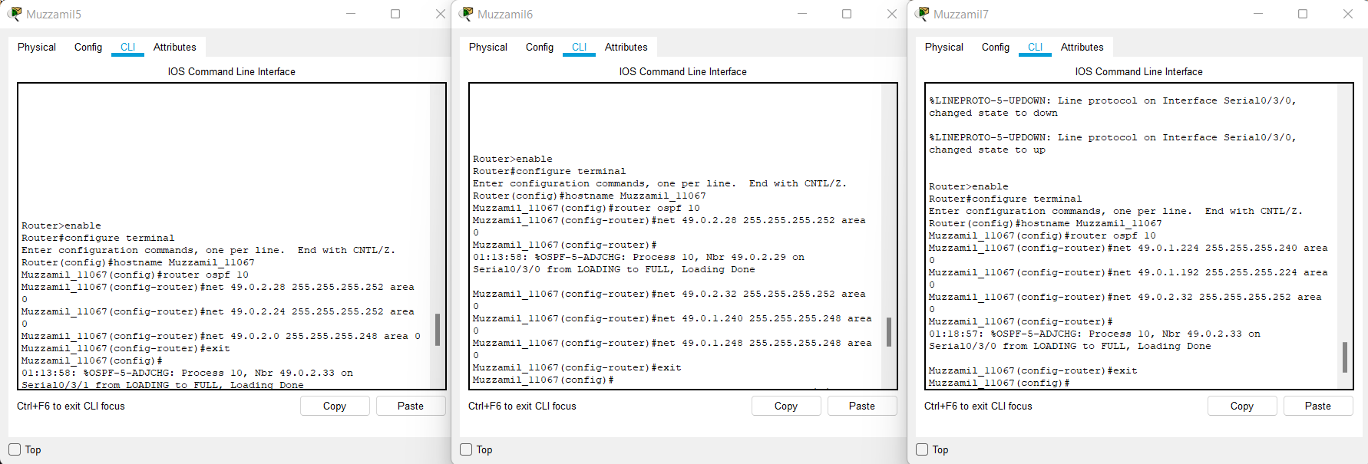

**OSPF ROUTING TABLES:**

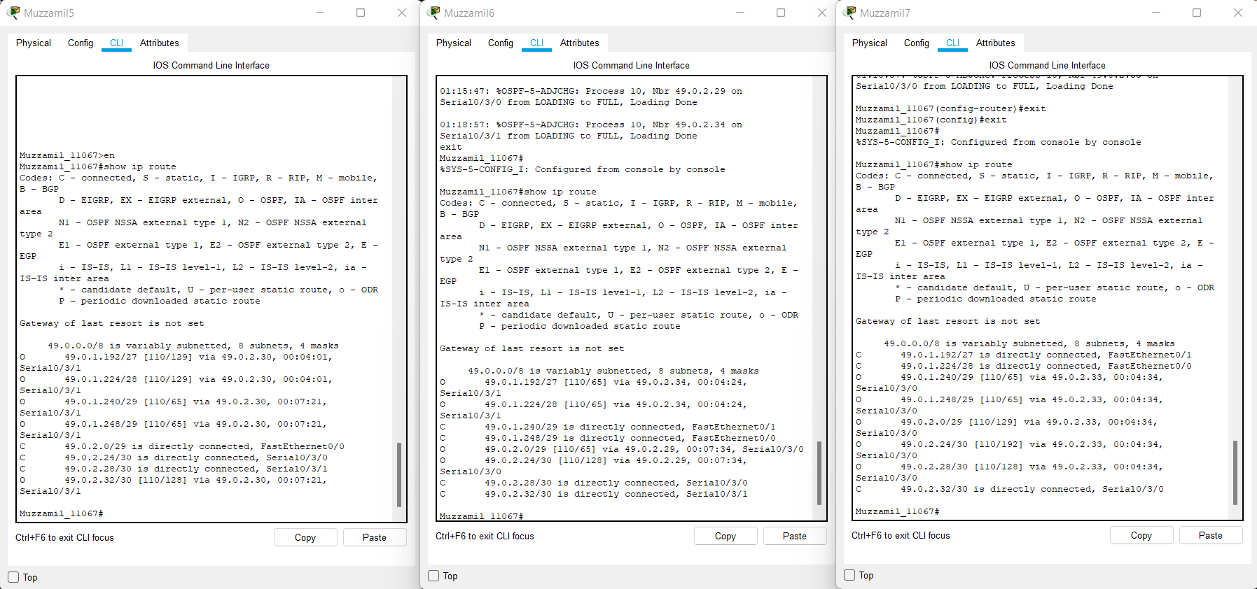

**REDISTRIBUTION CONFIGURATION:**

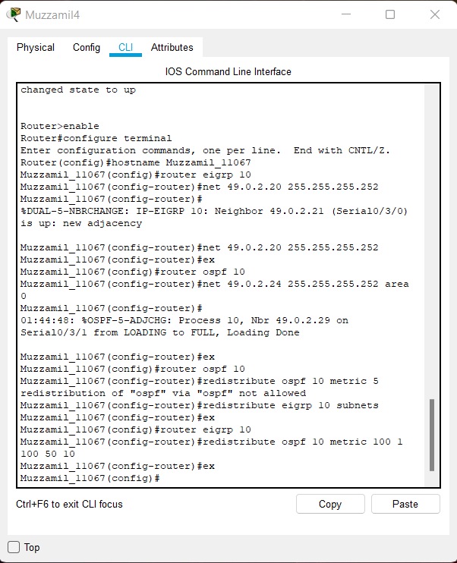

**REDISTRIBUTION ROUTING TABLES:**

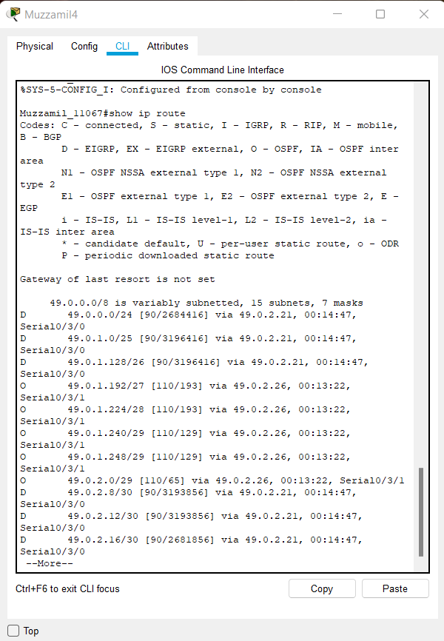

**ACL CONFIGURATION:**

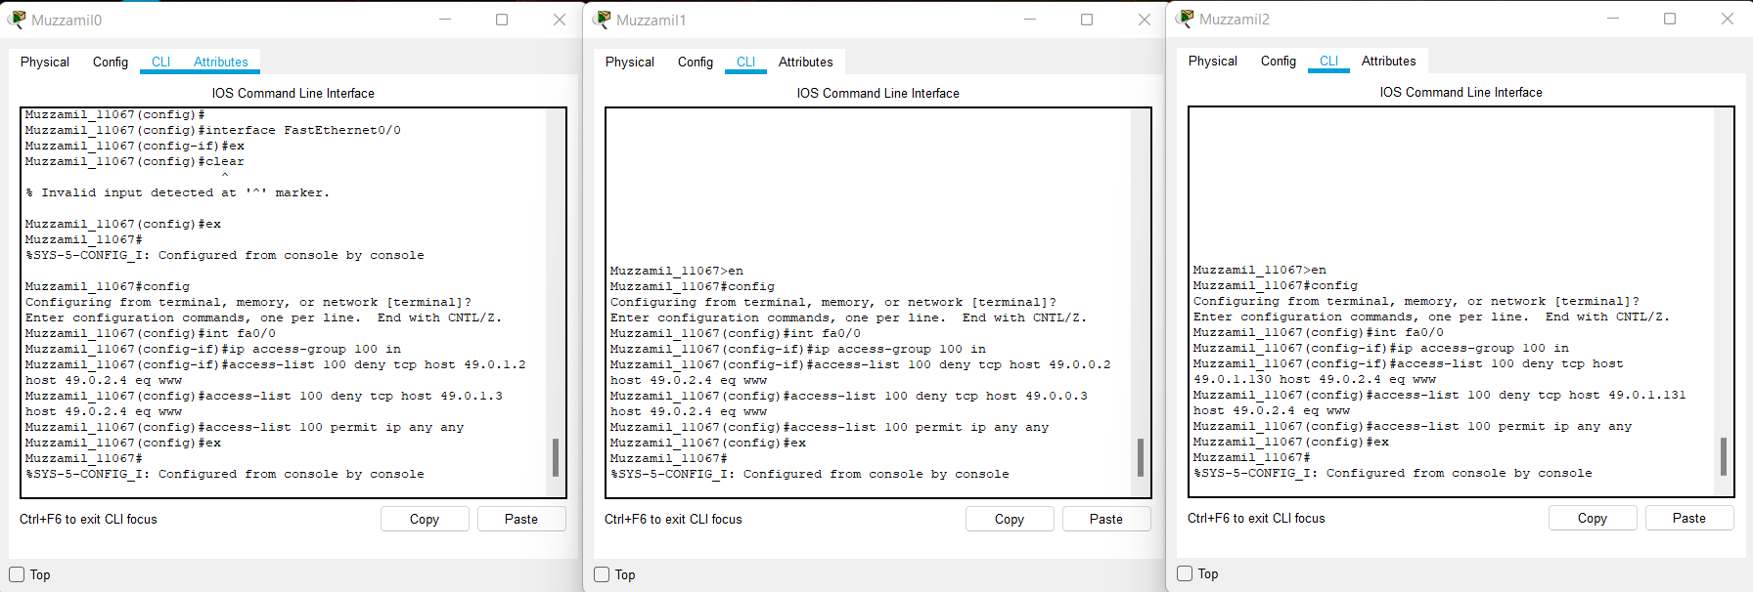

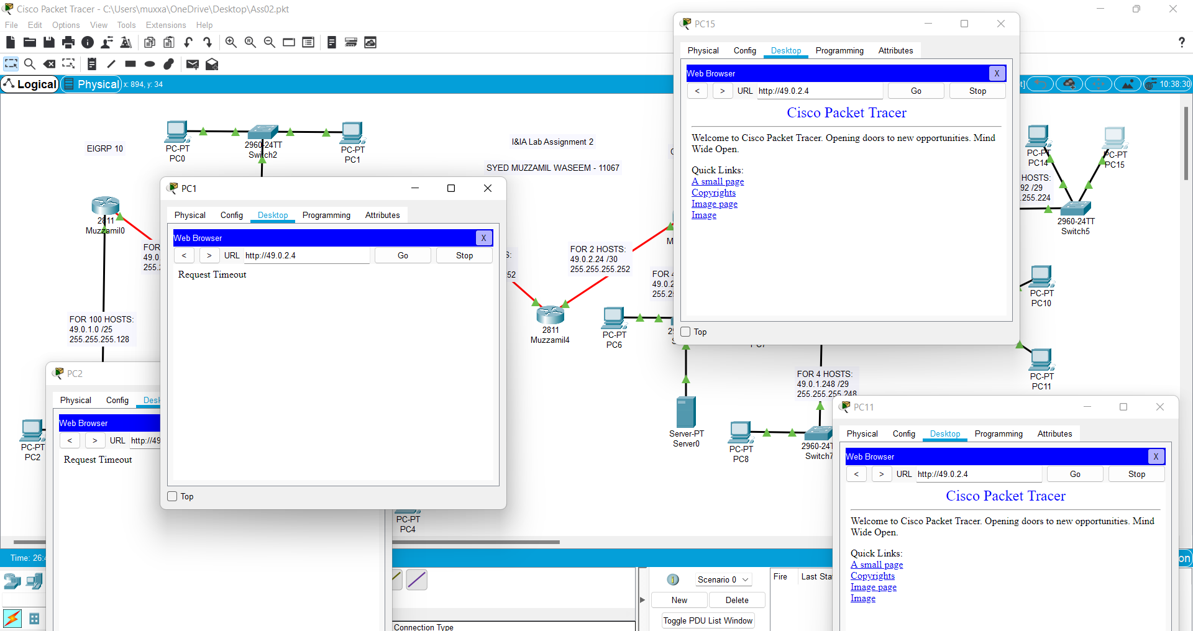

**SERVER ACCESS:**

